**Year 8 Physical Science  
Pendulum Energy Investigation**

**Background Information**

In this activity, you are going to use a simple pendulum to try and develop your understanding of the energy transformations involved.

You will be making observations about the **period** of your pendulum.

The period of a pendulum is the time taken for the pendulum to make one complete swing forwards and back to its starting position.

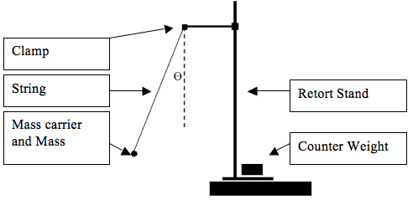**Equipment**

* retort stand
* string (about 1 m)
* boss head with clamp
* set of 4 slotted masses
* ruler
* tape
* a timer

**Method (Part A)**

1. Set up your equipment as shown in the diagram above. Make the string approximately 30 cm long and place four masses on the carrier.
2. Pull the masses to one side and let them go, allowing them to swing back and forth freely (without hitting anything).

**Discussion (Part A)**

After watching the pendulum swing, answer the following questions.

The pendulum has its:

Greatest potential energy when: ____________________________________________________________

Greatest kinetic energy when: ______________________________________________________________

The speed of the pendulum is greatest when it is: ______________________________________________

The speed of the pendulum is zero when it is: _________________________________________________

If allowed to continue swinging, would the pendulum keep swinging forever? Explain why or why not.

|  |
| --- |
|  |
|  |
|  |

**Method (Part B)**

1. Get your timer ready, then pull the masses back approximately ten centimetres.
2. Let go of the masses, starting the timer as you do.
3. Allow the masses to complete ten full swings (forwards and back), stopping the timer at the end of the tenth swing. Record the time for the ten swings in the table below under Trial 1 for Test 1.
4. Repeat steps 1 to 3 twice more, recording the times under Trials 2 and 3.
5. Calculate the average of your three trials and record it in your table. (Hint: your average should be somewhere in the middle of your values. If it’s larger or smaller than all of them, you’ve made a mistake somewhere!)
6. Calculate the period of the pendulum by dividing your average by 10.

|  |  |  |  |  |  |
| --- | --- | --- | --- | --- | --- |
| **Test** | **Trial 1** | **Trial 2** | **Trial 3** | **Average** | **Period** |
| **1** |  |  |  |  |  |
| **2** |  |  |  |  |  |

**Method (Part C)**

1. Change the length of the string to 60 cm and remove two of the masses from the carrier.
2. Repeat Part C, but this time pull the masses back 20 cm each time. Record your results in the Test 2 row of the table.

**Discussion (Parts B and C)**

1. Was there any difference in the period for Test 1 and Test 2? If there was, what was it?

|  |
| --- |
|  |
|  |
|  |

1. If you answered yes: what do you think caused the difference in the periods?  
   If you answered no: why do you think the period stayed the same?

|  |
| --- |
|  |
|  |
|  |

1. Can you be certain that your answer to Q2 is correct? Why or why not? How could you find out?

|  |
| --- |
|  |
|  |
|  |
|  |
|  |
|  |